Data Science Unit 3: NumPy and pandas

Unit overview
Part | Syllabus topics | What it gives you
NumPy | Fast element-wise array functions, multidimensional arrays, data processing using arrays, file I/O with arrays | Quick maths on whole arrays without writing loops
pandas | Data structures, essential functionality, descriptive statistics, handling missing data, hierarchical indexing | Tables with row and column labels, ready for cleaning and analysis
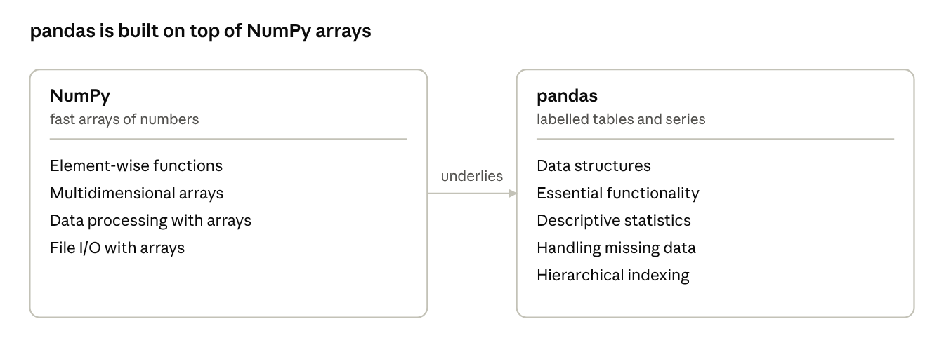
unit roadmap · NumPy and pandas

1. NumPy Basics
NumPy's core object is the ndarray, a grid of values of one type stored in one block of memory, which lets it apply an operation to millions of numbers in compiled C code instead of a slow Python loop.

1.1 Why NumPy is fast
- Homogeneous: every element has the same type, so no per-item type checks are needed.
- Contiguous memory: the values sit side by side, which suits the processor cache.
- Vectorized: one expression such as a * 2 runs a C loop over every element.
- Compact: an array of 1 million float64 numbers uses 8 MB; the same Python list uses several times more.
import numpy as np
data = [1, 2, 3, 4]
arr = np.array(data)
print(arr * 2) # [2 4 6 8] -> element-wise arithmetic
print(data * 2) # [1, 2, 3, 4, 1, 2, 3, 4] -> a list just repeats itself
print(arr.sum(), arr.mean()) # 10 2.5

1.2 Creating arrays and their attributes
Function | Result | Example
np.array(seq) | Array from a list or tuple | np.array([1, 2, 3])
np.zeros(shape) / np.ones(shape) | Arrays filled with 0 / 1 | np.zeros((2, 3))
np.arange(start, stop, step) | Like range, returns an array | np.arange(0, 10, 2) gives [0 2 4 6 8]
np.linspace(a, b, n) | n evenly spaced values from a to b | np.linspace(0, 1, 5)
np.eye(n) | Identity matrix | np.eye(3)
np.random.rand(...) | Random numbers between 0 and 1 | np.random.rand(2, 2)
np.full(shape, v) | Array filled with v | np.full((2, 2), 7)

Attribute | Meaning
a.shape | Size along each axis, as a tuple such as (3, 4)
a.ndim | Number of axes (dimensions)
a.size | Total number of elements
a.dtype | Data type of the elements
a.itemsize | Bytes used by one element
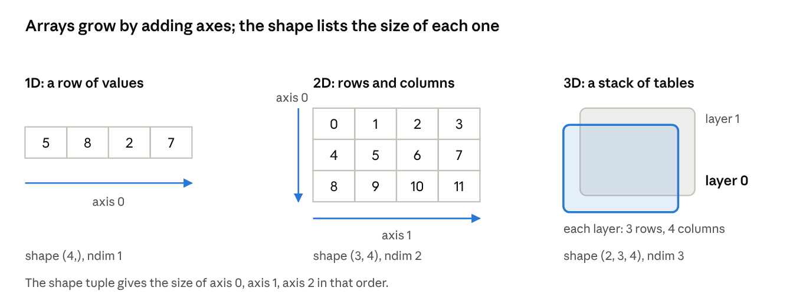
1D, 2D and 3D arrays · axes and shape
Common data types are int32, int64, float32, float64, bool and str_. Convert with a.astype(np.float64); converting a float array to int drops the decimals.

1.3 Fast element-wise array functions
Operators and universal functions (ufuncs) act on every element at once and return a new array of the same shape.
a = np.array([1.0, 4.0, 9.0])
b = np.array([2.0, 2.0, 2.0])
print(a + b) # [ 3. 6. 11.]
print(a * b) # [ 2. 8. 18.]
print(a ** 2) # [ 1. 16. 81.]
print(np.sqrt(a)) # [1. 2. 3.]
print(np.maximum(a, 5)) # [5. 5. 9.] -> element-wise maximum
print(a > 3) # [False True True] -> comparison gives a bool array
Kind | Examples
Unary (one array) | np.abs, np.sqrt, np.square, np.exp, np.log, np.sin, np.ceil, np.floor, np.rint, np.isnan
Binary (two arrays) | np.add, np.subtract, np.multiply, np.divide, np.power, np.maximum, np.minimum, np.mod, np.greater, np.logical_and
Broadcasting lets arrays of different shapes work together. NumPy compares the shapes from the last axis backwards; two sizes are compatible when they are equal or one of them is 1, and the size-1 axis is stretched to match.
m = np.array([[1, 2, 3],
[4, 5, 6]]) # shape (2, 3)
v = np.array([10, 20, 30]) # shape (3,)
print(m + v) # v is stretched down both rows
# [[11 22 33]
# [14 25 36]]
print(m * 10) # a single number is stretched everywhere
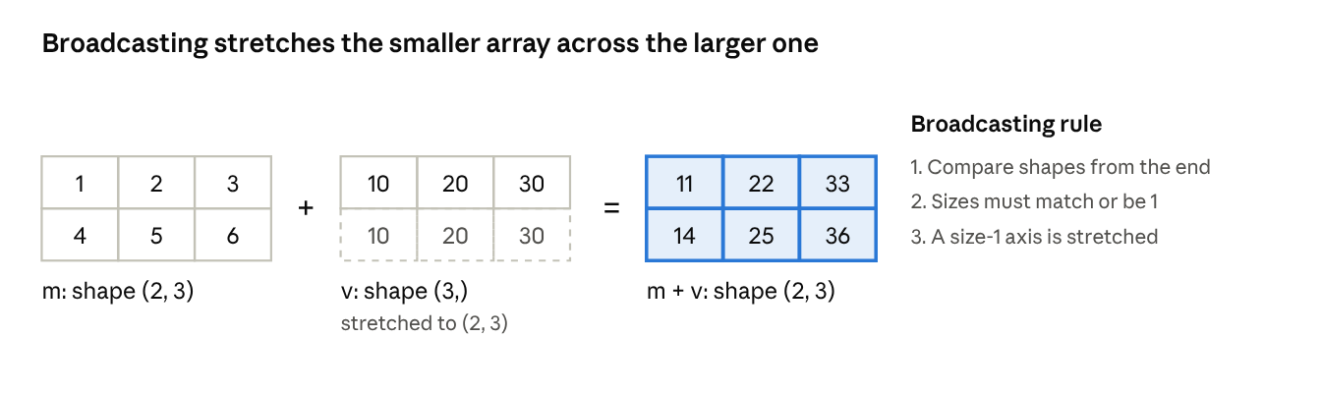
broadcasting a (3,) array over (2, 3)

1.4 Multidimensional arrays
A 2D array has rows (axis 0) and columns (axis 1); a 3D array adds a third axis (axis 0 then selects a whole 2D layer). Index with commas inside one pair of brackets: a[row, column].
a = np.arange(12).reshape(3, 4)
# [[ 0 1 2 3]
# [ 4 5 6 7]
# [ 8 9 10 11]]
print(a[1, 2]) # 6 one element
print(a[:, 0]) # [0 4 8] first column
print(a[:2, 1:3]) # [[1 2] [5 6]] rows 0-1, columns 1-2
print(a[a > 6]) # [ 7 8 9 10 11] boolean indexing
print(a[[0, 2]]) # rows 0 and 2 fancy indexing with a list
print(a.T.shape) # (4, 3) transpose swaps the axes
print(a.reshape(2, 6).shape) # (2, 6)
print(a.ravel()) # flattened to 1D
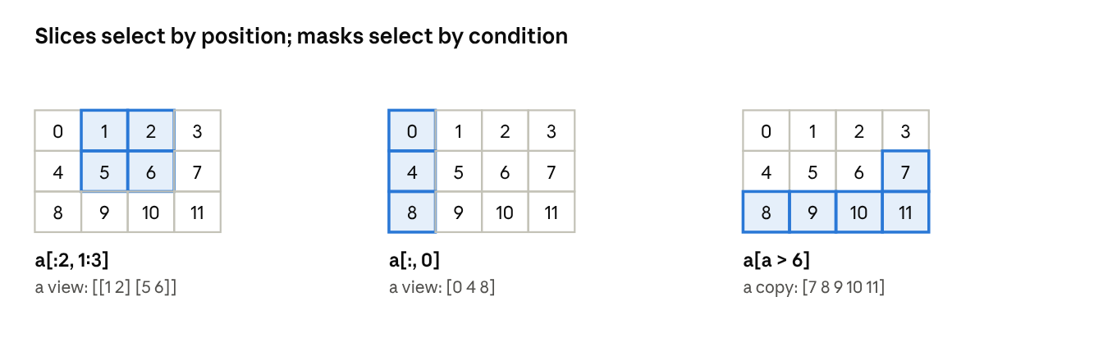
slicing and boolean indexing · 3 examples
Indexing style | Syntax | Returns
Basic slicing | a[1:3, :2] | A view: shares memory with a
Boolean mask | a[a > 6] | A copy of the selected items
Fancy indexing | a[[0, 2]] | A copy of the selected rows
Because a slice is a view, changing it changes the original array too: b = a[0]; b[0] = 99 also changes a[0, 0]. Use a[0].copy() when you need an independent array. To join arrays use np.concatenate, np.vstack (stack rows) and np.hstack (stack columns).

2. Data Processing Using Arrays and File I/O
Array-oriented programming means expressing a calculation on whole arrays instead of looping over items; it is shorter, faster and the style every later library expects.

2.1 Conditional logic with np.where
np.where(condition, a, b) is a vectorized if-else: it picks from a where the condition is true and from b elsewhere.
import numpy as np
temps = np.array([28, 35, 31, 22])
print(np.where(temps > 30, "hot", "ok")) # ['ok' 'hot' 'hot' 'ok']
scores = np.array([45, 82, 67, 30])
print(np.where(scores >= 40, scores, 0)) # [45 82 67 0]

2.2 Mathematical and statistical methods
These methods summarise an array. Without an argument they use every element; the axis argument chooses the direction.
Method | Meaning
sum, mean, std, var | Total, average, standard deviation, variance
min, max | Smallest and largest value
argmin, argmax | Position of the smallest and largest value
cumsum, cumprod | Running total and running product
a = np.array([[1, 2, 3],
[4, 5, 6]])
print(a.sum()) # 21
print(a.sum(axis=0)) # [5 7 9] collapse the rows: one total per column
print(a.sum(axis=1)) # [ 6 15] collapse the columns: one total per row
print(a.mean(axis=0)) # [2.5 3.5 4.5]
print(a.cumsum()) # [ 1 3 6 10 15 21]
print(a.argmax()) # 5 (position in the flattened array)
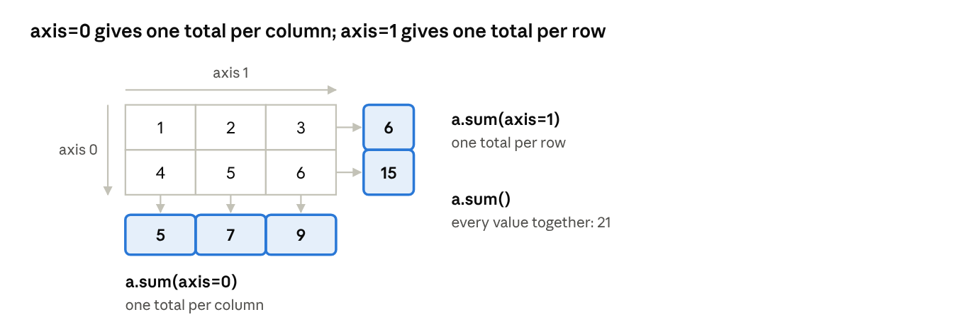
axis=0 and axis=1 sums

2.3 Methods for boolean arrays
A comparison gives an array of True and False, which counts as 1 and 0 in arithmetic, so you can count matches with sum().
marks = np.array([72, 35, 88, 41])
passed = marks >= 40
print(passed.sum()) # 3 how many passed
print(passed.any()) # True at least one passed
print(passed.all()) # False not everyone passed

2.4 Sorting and set logic
v = np.array([3, 1, 2, 3, 1])
print(np.sort(v)) # [1 1 2 3 3]
print(np.argsort(v, kind="stable")) # [1 4 2 0 3] positions that would sort v
print(np.unique(v)) # [1 2 3] sorted unique values
print(np.isin(v, [1, 2])) # [False True True False True]
print(np.intersect1d(v, [2, 3, 9])) # [2 3]
Other set functions are np.union1d and np.setdiff1d. Use a.sort() to sort in place and np.sort(a) to get a sorted copy.

2.5 Linear algebra and random numbers
A = np.array([[2, 1],
[1, 3]])
b = np.array([3, 5])
print(A @ A) # matrix product: [[ 5 5] [ 5 10]]
print(A.T) # transpose
print(np.linalg.solve(A, b)) # solves 2x + y = 3 and x + 3y = 5 -> [0.8 1.4]
print(np.linalg.det(A)) # determinant, about 5.0
rng = np.random.default_rng(seed=42) # reproducible random numbers
print(rng.normal(size=3)) # 3 draws from a standard normal distribution
A * A multiplies element by element, while A @ A (or np.dot) is true matrix multiplication; do not confuse them.

2.6 File input and output with arrays
Function | Format | Use
np.save(file, arr) / np.load(file) | Binary .npy | Fast, exact storage of one array
np.savez(file, a=..., b=...) | Binary .npz archive | Several arrays in one file
np.savetxt(file, arr, delimiter=",") | Text (CSV-like) | Human-readable files
np.loadtxt(file, delimiter=",") | Text | Read clean numeric text files
np.genfromtxt(file, delimiter=",") | Text | Read text files that contain missing values
arr = np.arange(6).reshape(2, 3)
np.save("data.npy", arr) # binary, keeps dtype and shape
print(np.load("data.npy"))
np.savez("pack.npz", first=arr, second=arr * 2)
pack = np.load("pack.npz")
print(pack["second"]) # [[ 0 2 4] [ 6 8 10]]
np.savetxt("data.csv", arr, delimiter=",", fmt="%d")
print(np.loadtxt("data.csv", delimiter=",")) # values come back as floats by default

3. pandas Data Structures
pandas adds labels to NumPy-style data: a Series is a labelled column of values, and a DataFrame is a table of such columns that share one row index.

3.1 Series
A Series is a one-dimensional array with an index of labels. Each value is reached by its label, not only by its position.
import pandas as pd
s = pd.Series([72, 85, 91], index=["Asha", "Ravi", "Meena"], name="marks")
print(s["Ravi"]) # 85 select by label
print(s.iloc[0]) # 72 select by position
print(s[s > 80]) # Ravi 85, Meena 91 boolean filter
print(s * 2) # arithmetic keeps the labels
print(s.values, s.index)
d = {"CSE": 120, "IT": 90}
print(pd.Series(d)) # a dictionary becomes labels and values

3.2 DataFrame
A DataFrame is a two-dimensional table with a row index and column labels. Each column is a Series and may have its own data type.
df = pd.DataFrame({
"name": ["Asha", "Ravi", "Meena", "Kiran"],
"dept": ["CSE", "IT", "CSE", "IT"],
"marks": [72, 85, 91, 64],
})
print(df.shape) # (4, 3)
print(df.columns.tolist()) # ['name', 'dept', 'marks']
print(df.dtypes) # name object, dept object, marks int64
print(df.head(2)) # first 2 rows
df.info() # columns, types, non-null counts
df["passed"] = df["marks"] >= 40 # add a column
del df["passed"] # remove it again
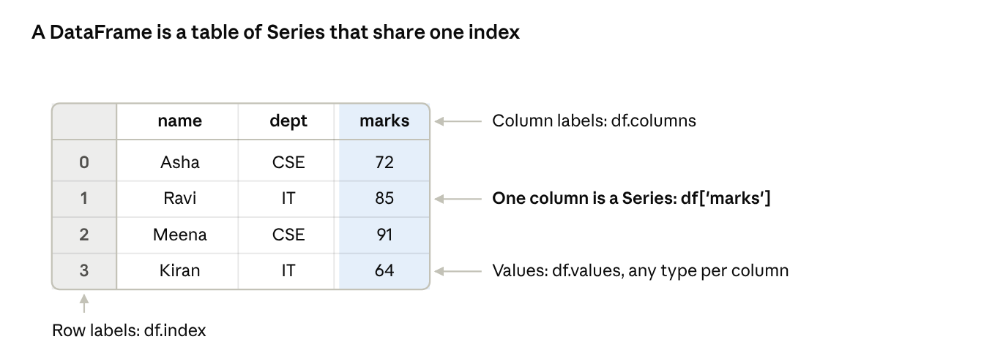
DataFrame anatomy · index, columns, values
Common ways to build a DataFrame: a dictionary of lists (above), a list of dictionaries (one per row), a NumPy array with columns=[...], or a file with pd.read_csv("file.csv").

3.3 Index objects
The row labels and column labels are Index objects. They are immutable (you replace them instead of editing one label) and they may contain duplicates, although unique labels are easier to work with.
df2 = df.set_index("name") # use a column as the row labels
print(df2.loc["Asha", "marks"]) # 72
print(df2.reset_index().columns.tolist()) # ['name', 'dept', 'marks'] -> back to a default 0..n-1 index

3.4 Selecting data
Goal | Code | Returns
One column | df["marks"] | Series
Several columns | df[["name", "marks"]] | DataFrame
Rows by label | df.loc[0:2] | DataFrame; the end label is included
Rows and columns by label | df.loc[1, "marks"] | One value
Rows by position | df.iloc[0:2] | DataFrame; the end position is excluded
Rows and columns by position | df.iloc[1, 2] | One value
Rows by condition | df[df["marks"] > 70] | Rows where the test is true
Combined conditions | df[(df.marks > 60) & (df.dept == "IT")] | Use &, | and ~ with brackets, not and or or

4. Essential Functionality and Descriptive Statistics
The everyday pandas toolkit is reindexing, label-based arithmetic, applying functions, sorting and summarising; most of it works the same on a Series and a DataFrame.

4.1 Reindexing and dropping
reindex rearranges data to a new list of labels, inserting NaN (not a number, meaning missing) for labels that do not exist. drop removes rows or columns by label and returns a new object.
s = pd.Series([4.5, 7.2, -5.3], index=["c", "a", "b"])
print(s.reindex(["a", "b", "c", "d"])) # d becomes NaN
print(s.reindex(["a", "b", "c", "d"], fill_value=0)) # d becomes 0
print(s.drop("a")) # remove one row label
print(df.drop(columns=["dept"])) # remove a column
print(df.drop(index=[0, 1])) # remove rows 0 and 1

4.2 Arithmetic and data alignment
When you combine two objects, pandas first aligns them on their labels. A label found in only one object gives NaN in the result.
s1 = pd.Series([1, 2, 3], index=["a", "b", "c"])
s2 = pd.Series([10, 20, 30], index=["b", "c", "d"])
print(s1 + s2) # a NaN, b 12, c 23, d NaN
print(s1.add(s2, fill_value=0)) # a 1, b 12, c 23, d 30 treat a missing label as 0
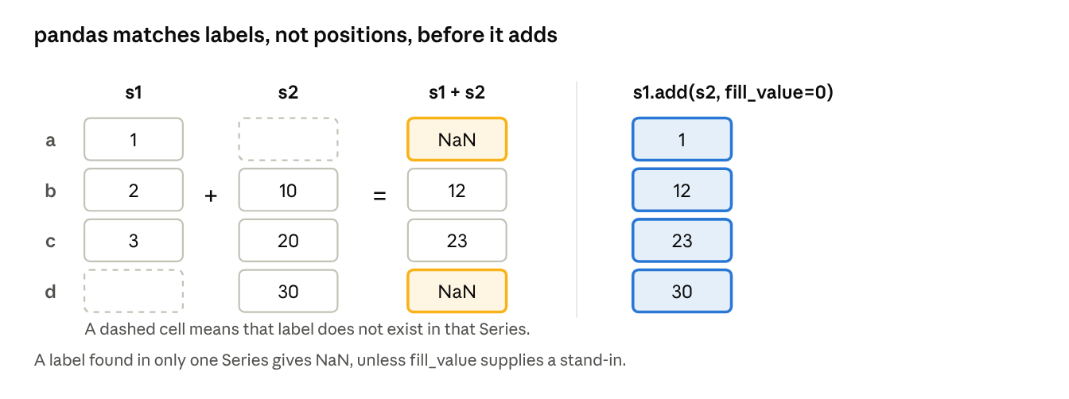
label alignment · s1 + s2
The methods add, sub, mul and div accept fill_value. A DataFrame combined with a Series is aligned on the columns by default and broadcast down the rows, as in NumPy.

4.3 Function application and mapping
- df.apply(func, axis=0) runs a function on each column (or each row with axis=1).
- series.map(func_or_dict) transforms every value of a Series, for example df["dept"].map({"CSE": "Computer", "IT": "Info Tech"}).
- df.map(func) applies a function to every single cell (older versions call this applymap).
- Many NumPy functions such as np.sqrt(df["marks"]) work directly on pandas objects.
rng = lambda col: col.max() - col.min() # a function of one column
print(df[["marks"]].apply(rng)) # marks 27
print(df["marks"].map(lambda m: "P" if m >= 40 else "F").tolist()) # ['P', 'P', 'P', 'P']

4.4 Sorting and ranking
print(df.sort_values("marks", ascending=False)) # highest marks first
print(df.sort_values(["dept", "marks"])) # by department, then marks
print(df.set_index("name").sort_index()) # sort by row labels
print(df["marks"].rank(ascending=False)) # 3.0, 2.0, 1.0, 4.0 -> rank 1 is the highest
rank gives each value its position in the sorted order; tied values share the average rank by default.

4.5 Summarizing and computing descriptive statistics
pandas statistics skip missing values by default (skipna=True). On a DataFrame they work column by column; use axis=1 to work across each row.
Method | What it returns
count() | Number of non-missing values
sum(), mean(), median() | Total, average, middle value
min(), max(), idxmin(), idxmax() | Extremes, and the label where they occur
std(), var() | Sample standard deviation and variance
quantile(q) | Value below which a fraction q of the data lies
cumsum(), cumprod() | Running totals and products
describe() | Count, mean, std, min, quartiles and max in one table
corr(), cov() | Correlation and covariance between columns
value_counts(), unique(), nunique() | Frequency of each value, distinct values, number of distinct values
print(df["marks"].describe())
# count 4.000000
# mean 78.000000
# std 12.247449
# min 64.000000
# 25% 70.000000
# 50% 78.500000
# 75% 86.500000
# max 91.000000
print(df["marks"].idxmax()) # 2 -> row label of the highest mark
print(df["dept"].value_counts()) # CSE 2, IT 2
print(df[["marks"]].corr()) # correlation matrix of numeric columns

5. Handling Missing Data
Real data always has gaps; pandas marks them as missing values so you can find them, drop them or fill them in, and so statistics do not break.

5.1 How missing data is represented
- NaN (not a number) marks a missing number in a float column.
- None marks a missing item in a text (object) column, and pandas treats it as missing too.
- NaT marks a missing date or time.
- pd.NA is the missing marker for the newer nullable data types.
isnull() (alias isna()) returns True where a value is missing, and notnull() is its opposite. Because True counts as 1, df.isnull().sum() gives the number of gaps in each column.
import numpy as np
import pandas as pd
data = pd.DataFrame({
"name": ["Asha", "Ravi", "Meena", "Kiran"],
"marks": [72, np.nan, 91, np.nan],
"city": ["Kochi", None, "Pune", "Delhi"],
})
print(data.isnull().sum()) # name 0, marks 2, city 1
print(data["marks"].mean()) # 81.5 missing values are skipped

5.2 Filtering out missing data
print(data.dropna()) # keeps only complete rows (Asha and Meena)
print(data.dropna(how="all")) # drops a row only if every value is missing
print(data.dropna(subset=["marks"])) # looks only at the marks column
print(data.dropna(axis=1)) # drops columns that contain any gap -> only name remains
print(data.dropna(thresh=3)) # keep rows that have at least 3 real values

5.3 Filling in missing data
print(data.fillna(0)) # one value for every gap
print(data.fillna({"marks": data["marks"].mean(), # a different value per column
"city": "Unknown"}))
vals = pd.Series([1, np.nan, np.nan, 4])
print(vals.ffill().tolist()) # [1.0, 1.0, 1.0, 4.0] copy the last valid value forward
print(vals.bfill().tolist()) # [1.0, 4.0, 4.0, 4.0] copy the next valid value backward
print(vals.interpolate().tolist()) # [1.0, 2.0, 3.0, 4.0] straight-line estimate
Situation | Usual choice
Few rows affected and the data is plentiful | dropna()
A whole column is mostly empty | Drop the column
A numeric column with random gaps | Fill with the mean or median
A category column | Fill with a label such as "Unknown" or the most frequent value
An ordered series such as daily readings | ffill() or interpolate()
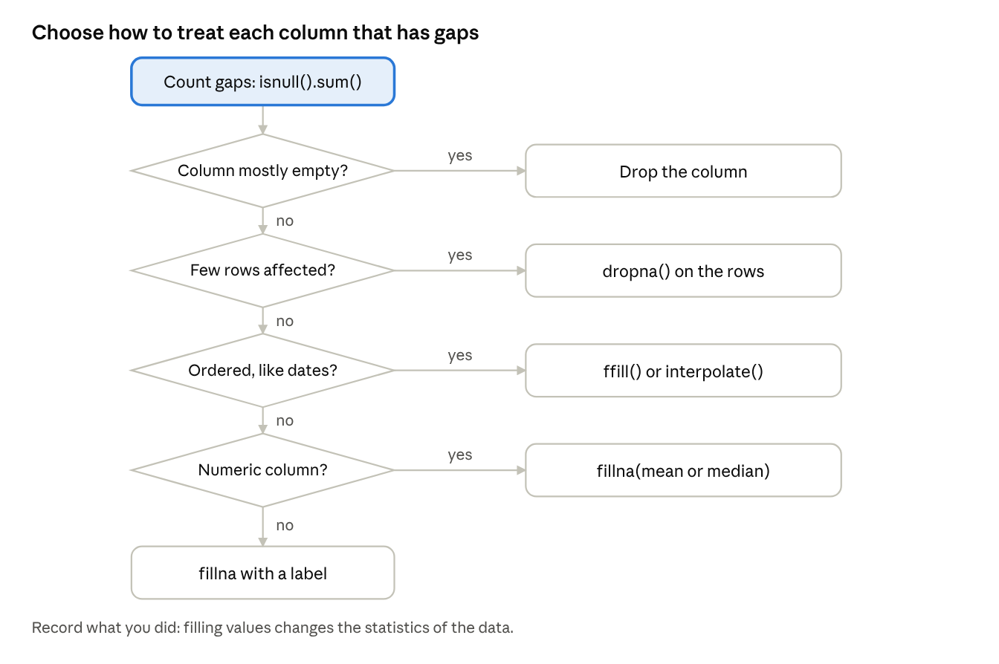
missing-data decision path · 4 questions
Always record what you did, because filling values changes the statistics of the data.

6. Hierarchical Indexing
Hierarchical indexing (a MultiIndex) gives an object two or more levels of row labels, so a table with several keys, such as department and year, can be handled as one structure.

6.1 MultiIndex on a Series
s = pd.Series([10, 20, 30, 40],
index=[["CSE", "CSE", "IT", "IT"],
[2025, 2026, 2025, 2026]])
print(s["CSE"]) # 2025 10, 2026 20 select the outer level
print(s.loc[:, 2026]) # CSE 20, IT 40 select the inner level
print(s.unstack()) # the inner level becomes the columns
# 2025 2026
# CSE 10 20
# IT 30 40
↗ stack and unstack · MultiIndex
unstack() pivots an index level into columns, and stack() does the reverse.

6.2 MultiIndex on a DataFrame
df = pd.DataFrame({
"dept": ["CSE", "CSE", "IT", "IT"],
"year": [2025, 2026, 2025, 2026],
"students": [10, 20, 30, 40],
}).set_index(["dept", "year"])
print(df.loc["CSE"]) # all years for CSE
print(df.loc[("IT", 2026), "students"]) # 40 a tuple selects one exact row
print(df.groupby(level="dept").sum()) # CSE 30, IT 70 statistics by one level
print(df.swaplevel().sort_index()) # year becomes the outer level
print(df.reset_index()) # turn the levels back into ordinary columns
Operation | Purpose
set_index(["a", "b"]) | Make columns into index levels
reset_index() | Move index levels back into columns
unstack() / stack() | Move a level between the rows and the columns
swaplevel() and sort_index() | Reorder the levels and sort so slicing works well
loc[(outer, inner)] | Select with a tuple of labels
groupby(level=...) | Summarise by one level
Columns can also have two levels, which is how a pivot table with several value columns is displayed.

Quick revision
Remember one core idea for each topic.
- ndarray: a fixed-type grid in contiguous memory; check shape, ndim and dtype first.
- Element-wise functions: operators and ufuncs such as np.sqrt and np.maximum act on every element without a loop.
- Broadcasting: compare shapes from the last axis; sizes must be equal or 1, and a size-1 axis is stretched.
- Indexing: slices are views (shared memory); boolean masks and fancy indexing return copies.
- Axis: axis=0 runs down the rows and gives one result per column; axis=1 runs across the columns and gives one result per row.
- Data processing: np.where for if-else, sum, mean, std, argmax, sort, unique and @ for matrix products.
- File I/O: np.save and np.load for binary .npy, np.savez for several arrays, np.savetxt, np.loadtxt and np.genfromtxt for text.
- Series and DataFrame: a labelled 1D array and a 2D table whose columns are Series.
- Selecting: loc uses labels (end included); iloc uses positions (end excluded).
- Alignment: arithmetic matches labels first, and unmatched labels give NaN; fill_value avoids that.
- Descriptive statistics: describe, mean, std, corr, value_counts; missing values are skipped by default.
- Missing data: isnull, dropna, fillna, ffill, interpolate.
- Hierarchical indexing: a MultiIndex gives several label levels; unstack and stack move a level between rows and columns.

Likely exam questions
Short answer (2 to 3 marks)
- What is an ndarray? Name any four of its attributes.
- What is broadcasting? Give an example.
- Differentiate between a view and a copy in NumPy.
- What does np.where do?
- Differentiate between loc and iloc.
- What is a Series? How does it differ from a NumPy array?
- Write the code to count the missing values in each column of a DataFrame.
Long answer (5 to 10 marks)
- Explain the creation of NumPy arrays and the fast element-wise functions, with examples.
- Explain multidimensional array indexing and slicing, with examples.
- Describe the mathematical and statistical methods, sorting and file I/O available for NumPy arrays.
- Explain the pandas data structures Series and DataFrame, with examples.
- Explain reindexing, data alignment and sorting in pandas.
- Explain how pandas computes descriptive statistics, with an example using describe.
- Explain the methods for handling missing data.
- Explain hierarchical indexing and the use of stack and unstack.

References

Text books
- Mark Lutz, Learning Python, O'Reilly.
- Mark Lutz, Programming Python, O'Reilly.
- Wes McKinney, Python for Data Analysis, O'Reilly (NumPy basics, pandas data structures, descriptive statistics, missing data and hierarchical indexing).

Reference books
- Martin C. Brown, Python: The Complete Reference, McGraw Hill Education.
- Paul Barry, Head First Python, O'Reilly.

